**From:** Littler, Adam - Communities <Adam.Littler@Oxfordshire.gov.uk>   
**Sent:** 18 October 2021 16:15  
**To:** Hudson, Mary - Communities <Mary.Hudson@Oxfordshire.gov.uk>  
**Subject:** RE: Comments overdue - MW.0115/21

Dear Mary,

LLFA comments as follows:

Documents reviewed:

WAL ES21-1 Location Map

WAL ES21-2 Site Plan

WAL ES21-3 Aerial Image

WAL ES21-5 Site Layout

WAL ES21-6 Conceptual Restoration

WAL PA21-4 Flood Map

WAL PA21-5 Site Plan

WCF Appx1 OCC-Pre-app advice

WhiteCross Farm_NTS Sept2021

WhiteCross farmSept2021- Application Forms_resubmisison

WQ ES Appx 2 – FRA

WQ ES Appx 3 – Hydrogeology

WQ ES Appx10 - Geology

Clarification email dated 14th September 2021 states:

*The main site lagoon is shown on the plans- dimensions 66m x 55m x 5m deep (thickest mineral deposit).*

*All surface water in the area of the plant will be directed into this lagoon.*

*As each phase progresses there will be a de-watering sump that will pump into the lagoon.*

*The overflow from the lagoon will be via a pipe to the ditch that forms the north-eastern site boundary that then discharges into the Thames. There will be no direct discharge from the workings into the Thames.*

Exceedance events and failure of the lagoon should be considered and management of such eventualities demonstrated.  Applicant to demonstrate whether the lagoon has an overflow mechanism for time of severe cumulative rainfall.

There are concerns over the surface water treatment and management train.  The applicant should prove that the lagoon will be sufficient to provide water quality improvements before discharge into the proposed ditch.

Justification is required that any overland flows will be treated before reaching the Thames.

Evidence of required permits required to satisfy the following statement:

***Groundwater:***

*So the mineral can be extracted ‘dry’, it will need to be*

*de-watered. De-watering and discharge during the*

*construction period would be controlled under a permit*

Evidence of this permit is required.

Drainage and flooding

The Lead Local Flood Authority Team have issued standing pre-application advice, which is in Annex 1. If further information is required, they would be happy to set up a separate meeting. They have their own charging system for pre-application advice. They require sustainable drainage solutions aligned with OCC local standards.

For further advice please contact the Lead Local Flood Authority team: [LLFAPlanningService@Oxfordshire.gov.uk](mailto:LLFAPlanningService@Oxfordshire.gov.uk)

Drawing WAL PA21-4 Flood Map indicates the site is in Flood Zone 3:

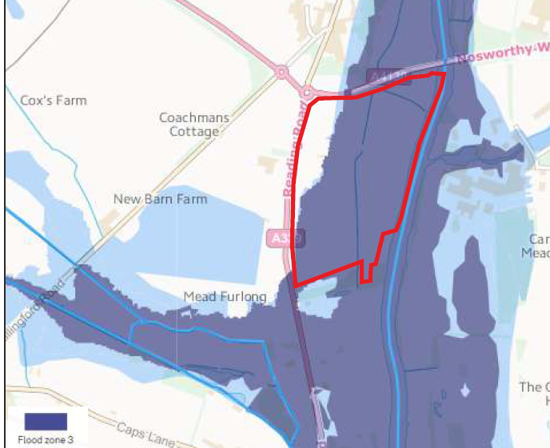

Environment Agency advice should be sought before commencement.

Groundwater monitoring should be undertaken for the duration of the proposed works.

Calculation files demonstrating that surface water flow will be maintained to Greenfield discharge rates for all relevant return periods, including a 40% Climate Change allowance.

There seems to be a lack of information regarding mitigated surface water flows post remediation, especially if this is to be done using clay materials

Evidence of consent to discharge into ordinary watercourses is required to be provided.

I hope this helps, there appear to be some fundamental detail missing from the submission.

Kind regards,

Adam.